Assignment-1
Create 3 private github repositories Repo1, Repo2 and Repo3. Create 3 branches, 1 for each repo 2026Q1,2026Q2 and 2026Q3. Add index.html file in each repo with some details about repo and branch. Create 3 jobs, for each job the index file should be deployed to deployment folder Job1 for 2026Q1, Job2 for 2026Q2, Job3 for 2026Q3. Httpd should be running on Jenkins master.
- Created 3 private repositories in github
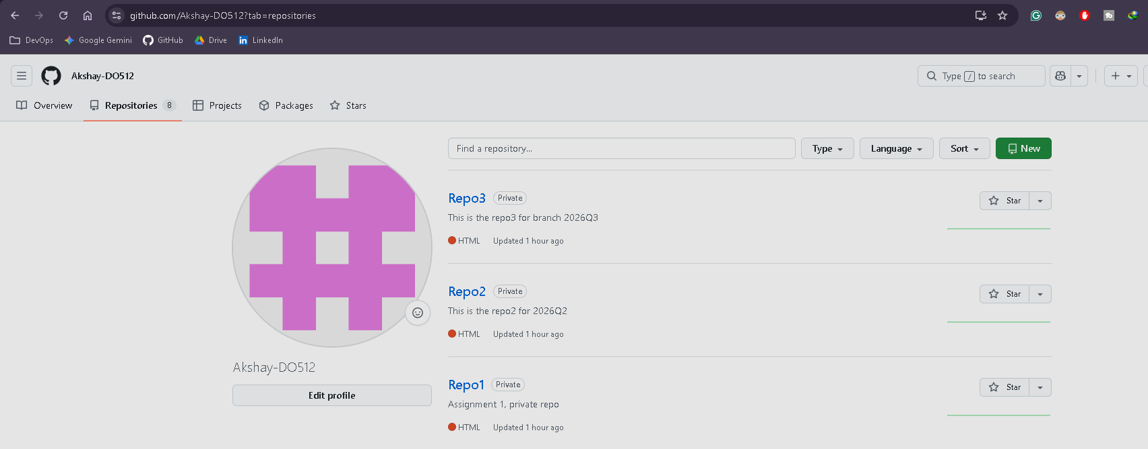

- Created 3 directories on JM and pushed index.html files to each branch
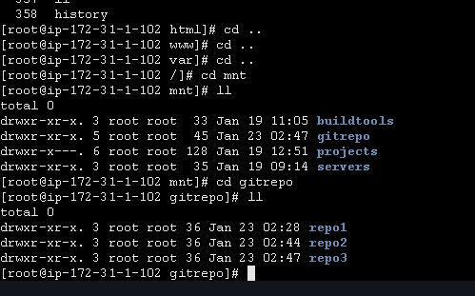
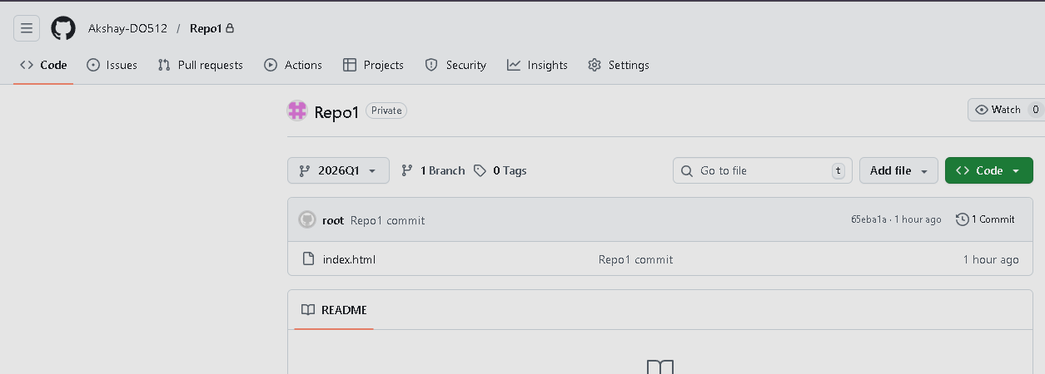
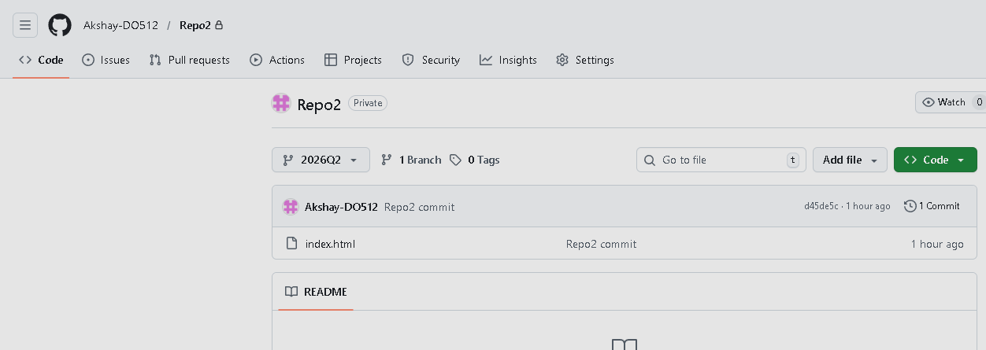
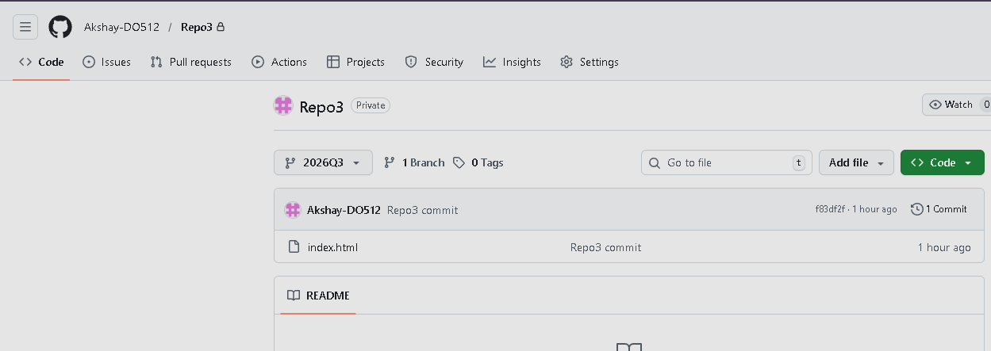

- Created 3 jobs on Jenkins for each repo/branch

Repo1-Job1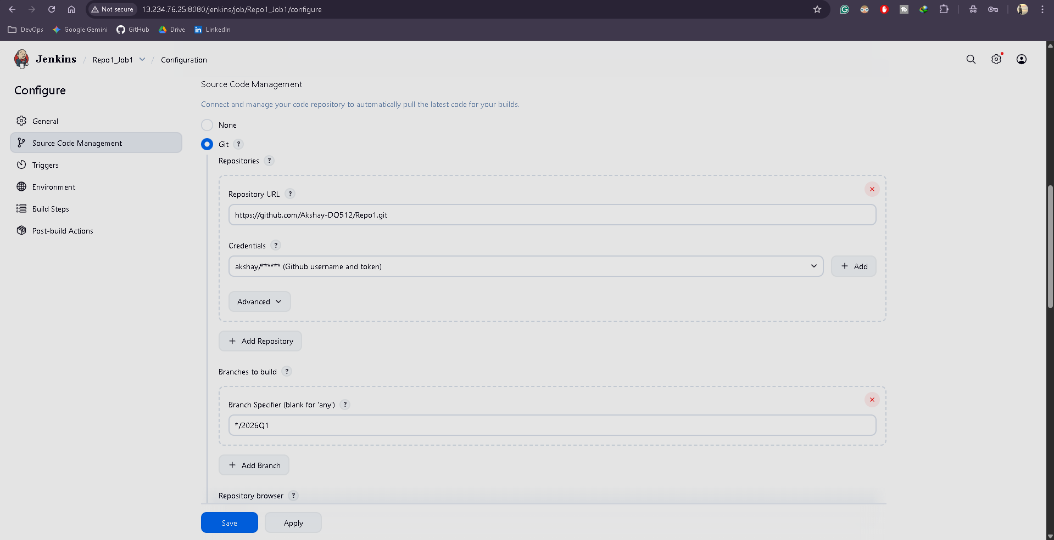
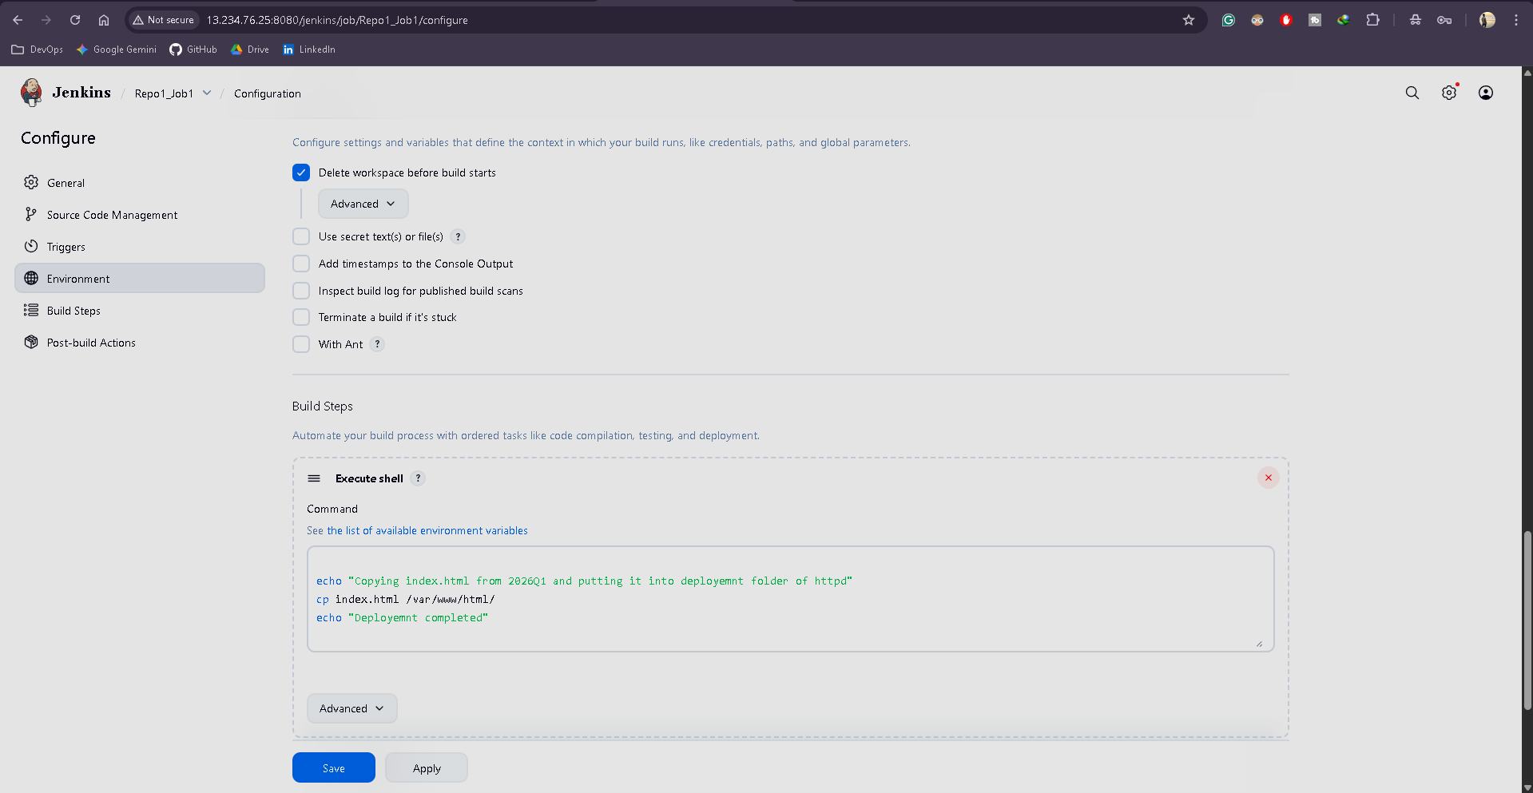

Repo2-job2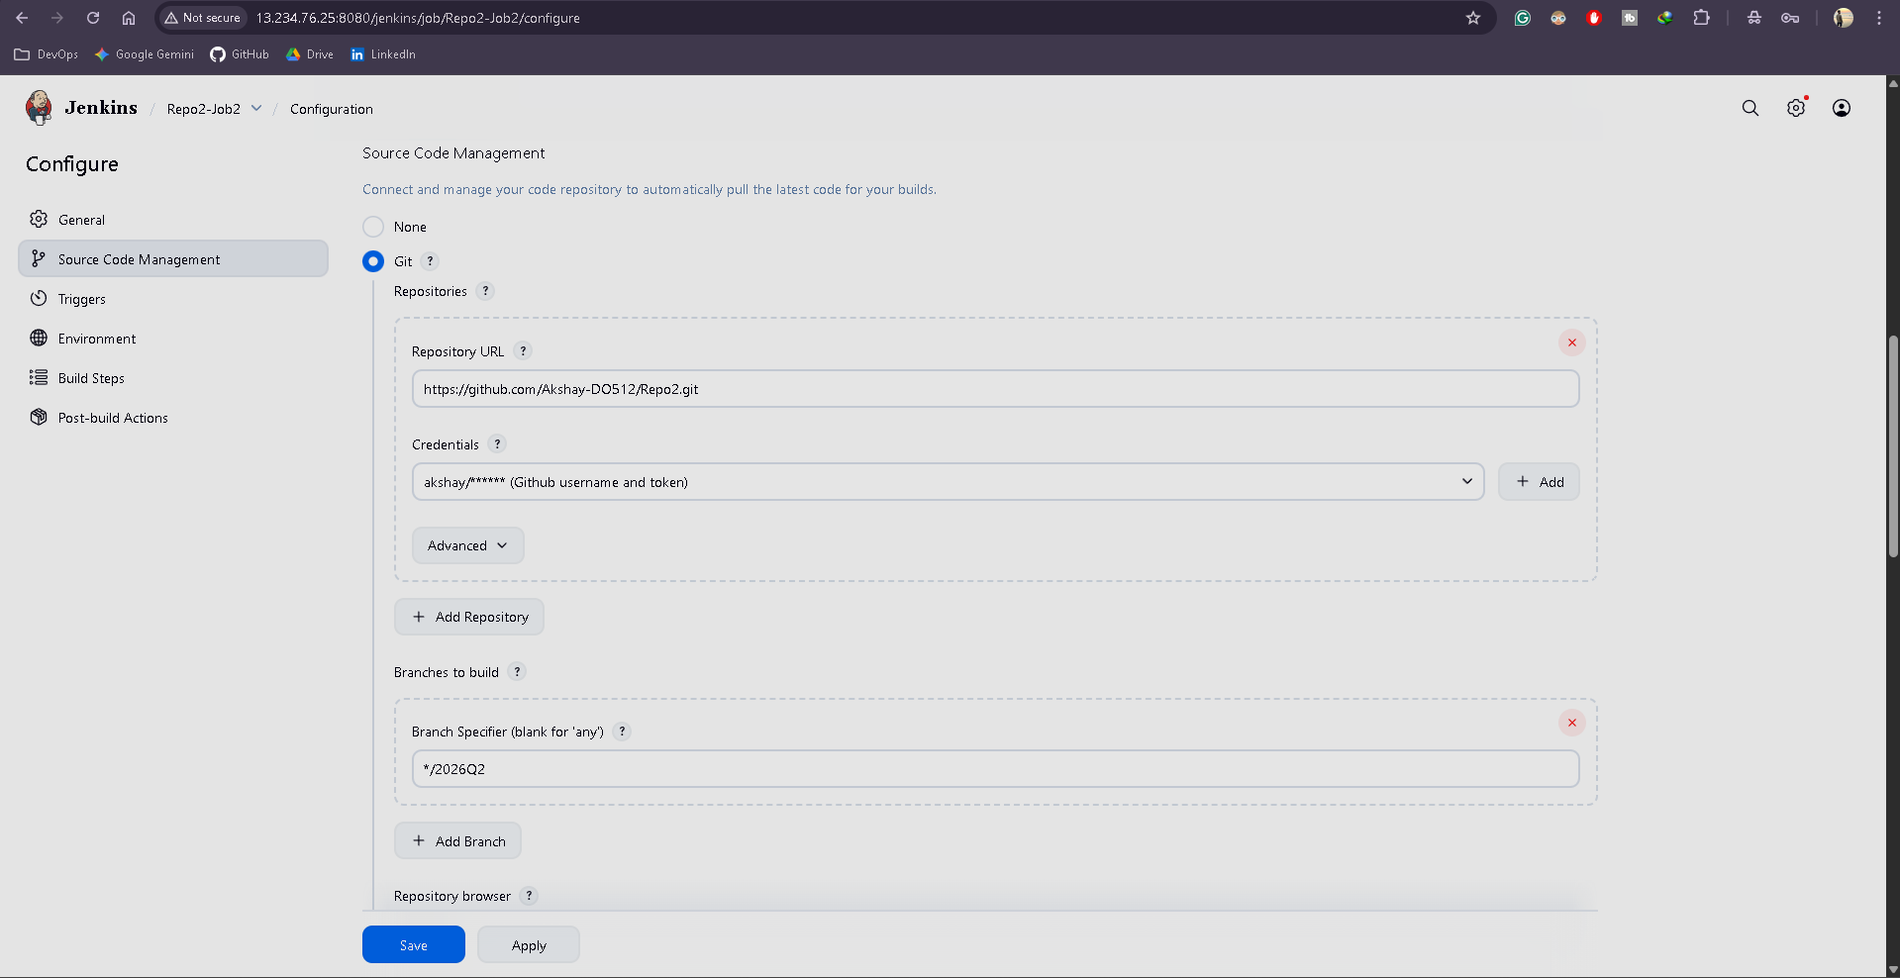
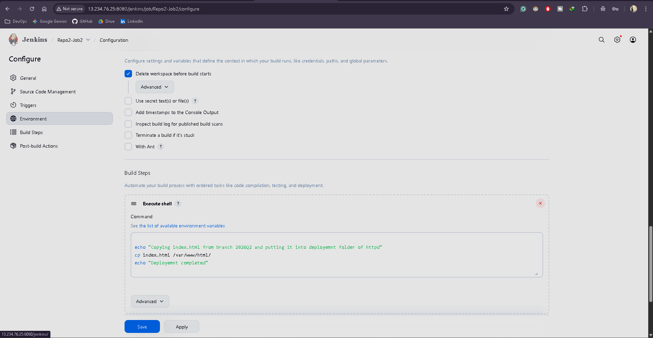

Repo3-Job3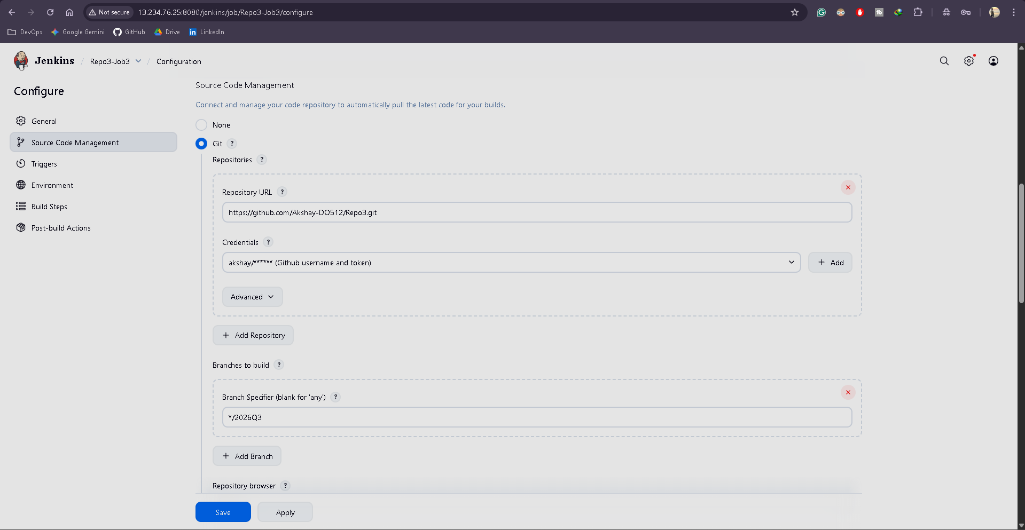
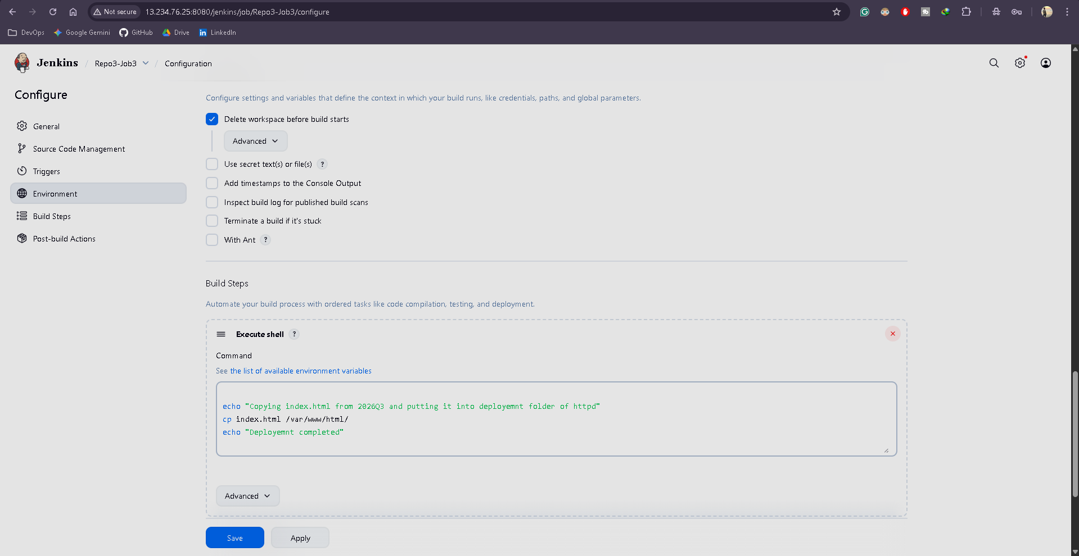

Output: Ran each job one by one and checked the output

- Ran Repo1-Job1
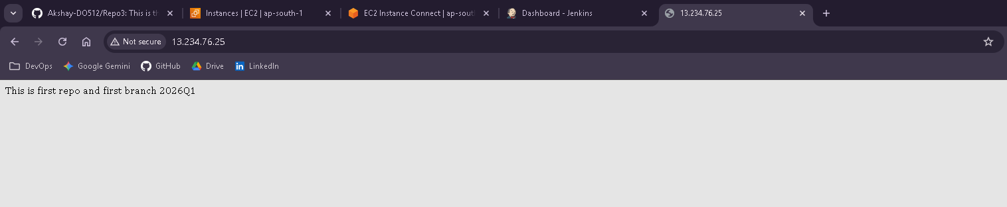

- Ran Repo2-Job2
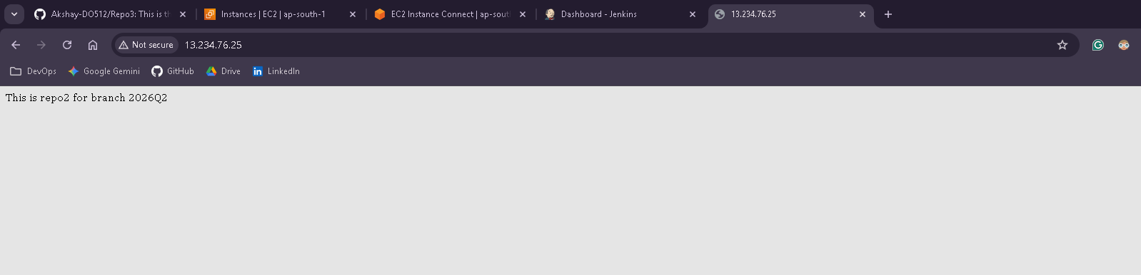

- Ran Repo3-job3
